SANTIAGO, DOMINICAN REPUBLIC

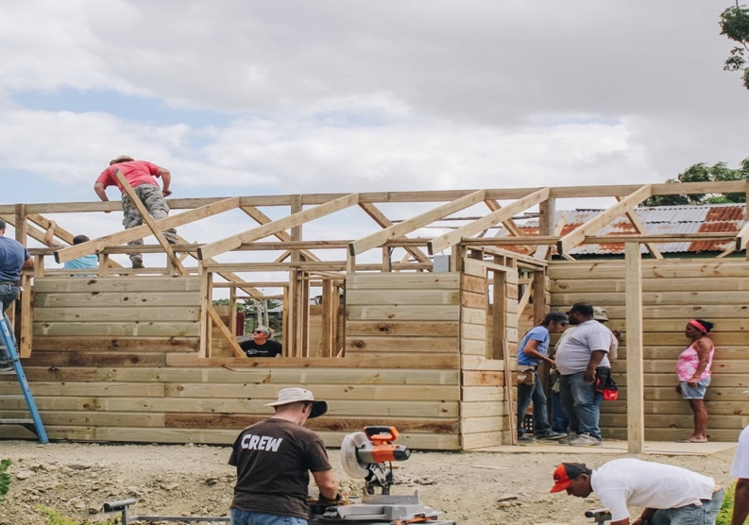

TRIP DATES: July 7th – 13th, 2024
APPLICATIONS DUE: 2/15/24 - Apply Here or go onechapel.com/short-term-missions
PAYMENT DUE: $200 due at application acceptance; $500 due 3/15; $500 due 5/1;
Final due 6/1
LEADER: Lore Cottone Lore.cottone@onechapel.com
GROUP: 15 - 30 people
COST: *$1,800/person(all-inclusive including airfare. Doesn’t include meals during flights))
ACCOMMODATIONS: Casas Por Cristo Facility: 3–4-bedroom home with bunk beds.
INFO: A Casas Por Cristo group mission trip is an opportunity for people of all skill levels and backgrounds to come together to build a home for a family in need. No prior building experience is necessary to work on a team – just a desire to serve the Lord and the people of the Dominican. During this time, our team will build a home for a family from start to finish. We will have an experienced Casas Por Cristo staff missionary guiding us every step of the way. Our team will cover the cost of the project, therefore providing the home as a gift to the family in need.

Ages 5 and up are welcome! Number of children 12 years old and younger will be limited.
The cost of a child 12 and under will be $900 and must be accompanied by their parent(s).
Number of teens 13 – 17 will be limited = two teens per one adult chaperone.
NOTE: Passport required.
*Final cost may fluctuate due to travel. Team will be notified.

